

THE IIE’s VARSITY COLLEGE SANDTON

SUMMATIVE PROJECT ADDB7311

2024

DEVELOPMENT ASSIGNMENT | 2nd YEAR COHORT 2023
ASSESSMENT TYPE: | SUMMATIVE PROJECT
TOTAL HOURS: | 1000 Hours

NAME AND SURNAME: | Ayush Harduth
STUDENT NUMBER: | ST10365068
SCHOOL: | IIE Varsity College Sandton
PROGRAMME: | ADDB7311
LECTURER | Mfowabo Maphosa
.

Contents
Question 1 3
Question 2 7
Question 3 8
Question 4 10
Question 5 (Correct Output) 11
Question 5 (Matching Sample Output) 13
Question 6 15
Question 7 18
Question 8 20
Question 9 21
Question 10 22
References 27

Question 1
-- Creating VOLUNTEER table
CREATE TABLE VOLUNTEER (
VOL_ID VARCHAR2(10) PRIMARY KEY,
VOL_FNAME VARCHAR2(50) NOT NULL,
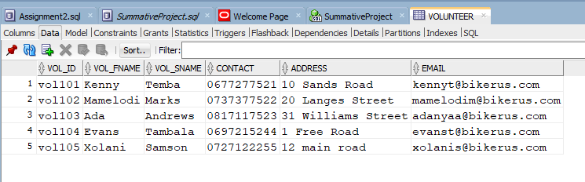
VOL_SNAME VARCHAR2(50) NOT NULL,
CONTACT VARCHAR2(15),
ADDRESS VARCHAR2(100),
EMAIL VARCHAR2(50)
);
-- Insert data into VOLUNTEER table

INSERT INTO VOLUNTEER (VOL_ID, VOL_FNAME, VOL_SNAME, CONTACT, ADDRESS, EMAIL) VALUES
('vol101', 'Kenny', 'Temba', '0677277521', '10 Sands Road', 'kennyt@bikerus.com');
INSERT INTO VOLUNTEER (VOL_ID, VOL_FNAME, VOL_SNAME, CONTACT, ADDRESS, EMAIL) VALUES
('vol102', 'Mamelodi', 'Marks', '0737377522', '20 Langes Street', 'mamelodim@bikerus.com');
INSERT INTO VOLUNTEER (VOL_ID, VOL_FNAME, VOL_SNAME, CONTACT, ADDRESS, EMAIL) VALUES
('vol103', 'Ada', 'Andrews', '0817117523', '31 Williams Street', 'adanyaa@bikerus.com');
INSERT INTO VOLUNTEER (VOL_ID, VOL_FNAME, VOL_SNAME, CONTACT, ADDRESS, EMAIL) VALUES
('vol104', 'Evans', 'Tambala', '0697215244', '1 Free Road', 'evanst@bikerus.com');
INSERT INTO VOLUNTEER (VOL_ID, VOL_FNAME, VOL_SNAME, CONTACT, ADDRESS, EMAIL) VALUES
('vol105', 'Xolani', 'Samson', '0727122255', '12 main road', 'xolanis@bikerus.com');

Constraints

-- Creating DONOR table
CREATE TABLE DONOR (
DONOR_ID VARCHAR2(10) PRIMARY KEY,
DONOR_FNAME VARCHAR2(50) NOT NULL,
DONOR_LNAME VARCHAR2(50) NOT NULL,
CONTACT_NO VARCHAR2(15),
EMAIL VARCHAR2(50)
);
INSERT INTO DONOR (DONOR_ID, DONOR_FNAME, DONOR_LNAME, CONTACT_NO, EMAIL) VALUES
('DID11', 'Jeff', 'Wanya', '0827172250', 'wanyajeff@ymail.com');
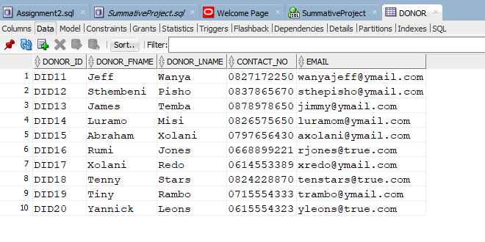
INSERT INTO DONOR (DONOR_ID, DONOR_FNAME, DONOR_LNAME, CONTACT_NO, EMAIL) VALUES
('DID12', 'Sthembeni', 'Pisho', '0837865670', 'sthepisho@ymail.com');
INSERT INTO DONOR (DONOR_ID, DONOR_FNAME, DONOR_LNAME, CONTACT_NO, EMAIL) VALUES
('DID13', 'James', 'Temba', '0878978650', 'jimmy@ymail.com');
INSERT INTO DONOR (DONOR_ID, DONOR_FNAME, DONOR_LNAME, CONTACT_NO, EMAIL) VALUES
('DID14', 'Luramo', 'Misi', '0826575650', 'luramom@ymail.com');
INSERT INTO DONOR (DONOR_ID, DONOR_FNAME, DONOR_LNAME, CONTACT_NO, EMAIL) VALUES
('DID15', 'Abraham', 'Xolani', '0797656430', 'axolani@ymail.com');
INSERT INTO DONOR (DONOR_ID, DONOR_FNAME, DONOR_LNAME, CONTACT_NO, EMAIL) VALUES
('DID16', 'Rumi', 'Jones', '0668899221', 'rjones@true.com');
INSERT INTO DONOR (DONOR_ID, DONOR_FNAME, DONOR_LNAME, CONTACT_NO, EMAIL) VALUES
('DID17', 'Xolani', 'Redo', '0614553389', 'xredo@ymail.com');
INSERT INTO DONOR (DONOR_ID, DONOR_FNAME, DONOR_LNAME, CONTACT_NO, EMAIL) VALUES
('DID18', 'Tenny', 'Stars', '0824228870', 'tenstars@true.com');
INSERT INTO DONOR (DONOR_ID, DONOR_FNAME, DONOR_LNAME, CONTACT_NO, EMAIL) VALUES
('DID19', 'Tiny', 'Rambo', '0715554333', 'trambo@ymail.com');
INSERT INTO DONOR (DONOR_ID, DONOR_FNAME, DONOR_LNAME, CONTACT_NO, EMAIL) VALUES
('DID20', 'Yannick', 'Leons', '0615554323', 'yleons@true.com');
-- Creating BIKE table
CREATE TABLE BIKE (
BIKE_ID VARCHAR2(10) PRIMARY KEY,
DESCRIPTION VARCHAR2(100),
BIKE_TYPE VARCHAR2(50),
MANUFACTURER VARCHAR2(50)
);
-- Insert data into BIKE table
INSERT INTO BIKE (BIKE_ID, DESCRIPTION, BIKE_TYPE, MANUFACTURER) VALUES ('B001', 'BMX AX1', 'Road Bike', 'BMX');
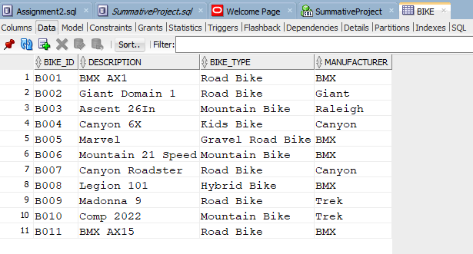
INSERT INTO BIKE (BIKE_ID, DESCRIPTION, BIKE_TYPE, MANUFACTURER) VALUES ('B002', 'Giant Domain 1', 'Road Bike', 'Giant');
INSERT INTO BIKE (BIKE_ID, DESCRIPTION, BIKE_TYPE, MANUFACTURER) VALUES ('B003', 'Ascent 26In', 'Mountain Bike', 'Raleigh');
INSERT INTO BIKE (BIKE_ID, DESCRIPTION, BIKE_TYPE, MANUFACTURER) VALUES ('B004', 'Canyon 6X', 'Kids Bike', 'Canyon');
INSERT INTO BIKE (BIKE_ID, DESCRIPTION, BIKE_TYPE, MANUFACTURER) VALUES ('B005', 'Marvel', 'Gravel Road Bike', 'BMX');
INSERT INTO BIKE (BIKE_ID, DESCRIPTION, BIKE_TYPE, MANUFACTURER) VALUES ('B006', 'Mountain 21 Speed', 'Mountain Bike', 'BMX');
INSERT INTO BIKE (BIKE_ID, DESCRIPTION, BIKE_TYPE, MANUFACTURER) VALUES ('B007', 'Canyon Roadster', 'Road Bike', 'Canyon');
INSERT INTO BIKE (BIKE_ID, DESCRIPTION, BIKE_TYPE, MANUFACTURER) VALUES ('B008', 'Legion 101', 'Hybrid Bike', 'BMX');
INSERT INTO BIKE (BIKE_ID, DESCRIPTION, BIKE_TYPE, MANUFACTURER) VALUES ('B009', 'Madonna 9', 'Road Bike', 'Trek');
INSERT INTO BIKE (BIKE_ID, DESCRIPTION, BIKE_TYPE, MANUFACTURER) VALUES ('B010', 'Comp 2022', 'Mountain Bike', 'Trek');
INSERT INTO BIKE (BIKE_ID, DESCRIPTION, BIKE_TYPE, MANUFACTURER) VALUES ('B011', 'BMX AX15', 'Road Bike', 'BMX');

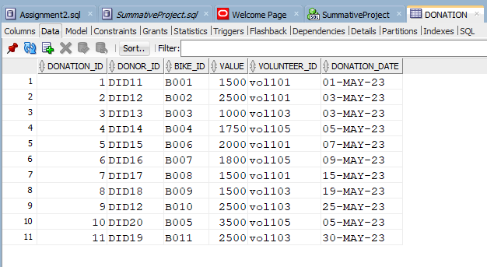
-- Creating DONATION table
CREATE TABLE DONATION (
DONATION_ID NUMBER PRIMARY KEY,
DONOR_ID VARCHAR2(10),
BIKE_ID VARCHAR2(10),
VALUE NUMBER,
VOLUNTEER_ID VARCHAR2(10),
DONATION_DATE DATE,
FOREIGN KEY (DONOR_ID) REFERENCES DONOR(DONOR_ID),
FOREIGN KEY (BIKE_ID) REFERENCES BIKE(BIKE_ID),
FOREIGN KEY (VOLUNTEER_ID) REFERENCES VOLUNTEER(VOL_ID)
);
-- Insert data into DONATION table
INSERT INTO DONATION (DONATION_ID, DONOR_ID, BIKE_ID, VALUE, VOLUNTEER_ID, DONATION_DATE) VALUES (1, 'DID11', 'B001', 1500, 'vol101', TO_DATE('01-May-2023', 'DD-Mon-YYYY'));
INSERT INTO DONATION (DONATION_ID, DONOR_ID, BIKE_ID, VALUE, VOLUNTEER_ID, DONATION_DATE) VALUES (2, 'DID12', 'B002', 2500, 'vol101', TO_DATE('03-May-2023', 'DD-Mon-YYYY'));
INSERT INTO DONATION (DONATION_ID, DONOR_ID, BIKE_ID, VALUE, VOLUNTEER_ID, DONATION_DATE) VALUES (3, 'DID13', 'B003', 1000, 'vol103', TO_DATE('03-May-2023', 'DD-Mon-YYYY'));
INSERT INTO DONATION (DONATION_ID, DONOR_ID, BIKE_ID, VALUE, VOLUNTEER_ID, DONATION_DATE) VALUES (4, 'DID14', 'B004', 1750, 'vol105', TO_DATE('05-May-2023', 'DD-Mon-YYYY'));
INSERT INTO DONATION (DONATION_ID, DONOR_ID, BIKE_ID, VALUE, VOLUNTEER_ID, DONATION_DATE) VALUES (5, 'DID15', 'B006', 2000, 'vol101', TO_DATE('07-May-2023', 'DD-Mon-YYYY'));
INSERT INTO DONATION (DONATION_ID, DONOR_ID, BIKE_ID, VALUE, VOLUNTEER_ID, DONATION_DATE) VALUES (6, 'DID16', 'B007', 1800, 'vol105', TO_DATE('09-May-2023', 'DD-Mon-YYYY'));
INSERT INTO DONATION (DONATION_ID, DONOR_ID, BIKE_ID, VALUE, VOLUNTEER_ID, DONATION_DATE) VALUES (7, 'DID17', 'B008', 1500, 'vol101', TO_DATE('15-May-2023', 'DD-Mon-YYYY'));
INSERT INTO DONATION (DONATION_ID, DONOR_ID, BIKE_ID, VALUE, VOLUNTEER_ID, DONATION_DATE) VALUES (8, 'DID18', 'B009', 1500, 'vol103', TO_DATE('19-May-2023', 'DD-Mon-YYYY'));
INSERT INTO DONATION (DONATION_ID, DONOR_ID, BIKE_ID, VALUE, VOLUNTEER_ID, DONATION_DATE) VALUES (9, 'DID12', 'B010', 2500, 'vol103', TO_DATE('25-May-2023', 'DD-Mon-YYYY'));
INSERT INTO DONATION (DONATION_ID, DONOR_ID, BIKE_ID, VALUE, VOLUNTEER_ID, DONATION_DATE) VALUES (10, 'DID20', 'B005', 3500, 'vol105', TO_DATE('05-May-2023', 'DD-Mon-YYYY'));
INSERT INTO DONATION (DONATION_ID, DONOR_ID, BIKE_ID, VALUE, VOLUNTEER_ID, DONATION_DATE) VALUES (11, 'DID19', 'B011', 2500, 'vol103', TO_DATE('30-May-2023', 'DD-Mon-YYYY'));

Question 2
SELECT
d.DONOR_ID,
b.BIKE_TYPE,
b.DESCRIPTION AS "Bike Description",
'R ' || d.VALUE AS "Bike Value"
FROM
DONATION d
JOIN
BIKE b ON d.BIKE_ID = b.BIKE_ID
WHERE
d.VALUE > 1500;

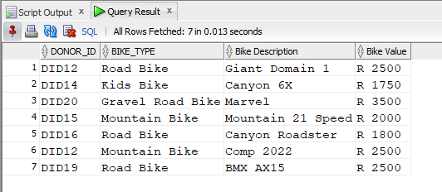

Question 3
DECLARE
v_vat CONSTANT NUMBER := 0.15; -- Declare VAT constant
v_description VARCHAR2(100);
v_manufacturer VARCHAR2(50);
v_bike_type VARCHAR2(50);
v_value NUMBER;
v_vat_amount NUMBER;
v_total_amount NUMBER;

CURSOR bike_cursor IS
SELECT
b.DESCRIPTION,
b.MANUFACTURER,
b.BIKE_TYPE,
d.VALUE
FROM
BIKE b
JOIN
DONATION d ON b.BIKE_ID = d.BIKE_ID
WHERE
b.BIKE_TYPE = 'Road Bike';
BEGIN
OPEN bike_cursor;
LOOP
FETCH bike_cursor INTO v_description, v_manufacturer, v_bike_type, v_value;
EXIT WHEN bike_cursor%NOTFOUND;

-- Calculate VAT and Total Amount
v_vat_amount := v_value * v_vat;
v_total_amount := v_value + v_vat_amount;

-- Display the results
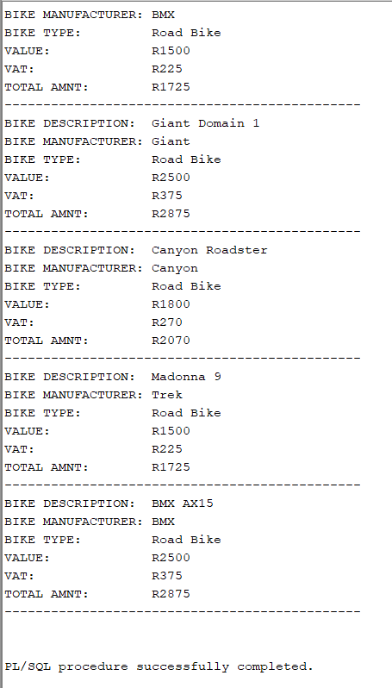
DBMS_OUTPUT.PUT_LINE('BIKE DESCRIPTION: ' || v_description);
DBMS_OUTPUT.PUT_LINE('BIKE MANUFACTURER: ' || v_manufacturer);
DBMS_OUTPUT.PUT_LINE('BIKE TYPE: ' || v_bike_type);
DBMS_OUTPUT.PUT_LINE('VALUE: R' || v_value);
DBMS_OUTPUT.PUT_LINE('VAT: R' || ROUND(v_vat_amount, 2));
DBMS_OUTPUT.PUT_LINE('TOTAL AMNT: R' || ROUND(v_total_amount, 2));
DBMS_OUTPUT.PUT_LINE('----------------------------------------------');
END LOOP;
CLOSE bike_cursor;
END;
/

Question 4

--Question 4
CREATE OR REPLACE VIEW vwBikeRUs AS
SELECT
d.DONOR_FNAME || ', ' || d.DONOR_LNAME AS DONOR_NAME,
d.CONTACT_NO,
b.BIKE_TYPE,
don.DONATION_DATE
FROM
DONOR d
JOIN
DONATION don ON d.DONOR_ID = don.DONOR_ID
JOIN
BIKE b ON don.BIKE_ID = b.BIKE_ID
WHERE
don.VOLUNTEER_ID = 'vol105';

--CODE TO VIEW THE VIEW
SELECT * FROM vwBikeRUs;

-- The view 'vwBikeRUs' combines donor information with bike and donation
-- details for donors assisted by volunteer 'vol105'.
-- This view simplifies data retrieval and enhances security by limiting the
-- dataset to relevant entries only.
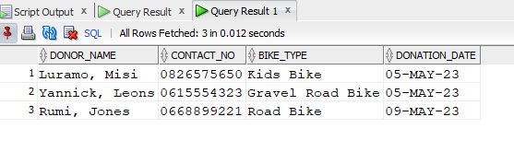

Question 5 (Correct Output)
-- Creating the stored procedure spDonorDetails
CREATE OR REPLACE PROCEDURE spDonorDetails(p_bike_id IN VARCHAR2) IS
-- Declare variables to hold the retrieved data
v_donor_name VARCHAR2(100);
v_contact_no VARCHAR2(15);
v_volunteer_fname VARCHAR2(50);
v_donation_date DATE;
BEGIN
-- Select statement to retrieve donor and donation details
SELECT
d.DONOR_FNAME || ' ' || d.DONOR_LNAME,
d.CONTACT_NO,
v.VOL_FNAME,
don.DONATION_DATE
INTO
v_donor_name,
v_contact_no,
v_volunteer_fname,
v_donation_date
FROM
DONOR d
JOIN
DONATION don ON d.DONOR_ID = don.DONOR_ID
JOIN
VOLUNTEER v ON don.VOLUNTEER_ID = v.VOL_ID
WHERE
don.BIKE_ID = p_bike_id;

-- Display the retrieved information
DBMS_OUTPUT.PUT_LINE('ATTENTION: ' || v_donor_name || ' assisted by: ' || v_volunteer_fname ||
', donated the bike with ID ' || p_bike_id || ' on the ' || TO_CHAR(v_donation_date, 'DD-MON-YY'));

EXCEPTION
WHEN NO_DATA_FOUND THEN
DBMS_OUTPUT.PUT_LINE('No donation found for the specified Bike ID.');
WHEN OTHERS THEN
DBMS_OUTPUT.PUT_LINE('An error occurred: ' || SQLERRM);
END;
/

-- Enable DBMS_OUTPUT
SET SERVEROUTPUT ON;

-- Execute the stored procedure
BEGIN
spDonorDetails('B004');
END;
/

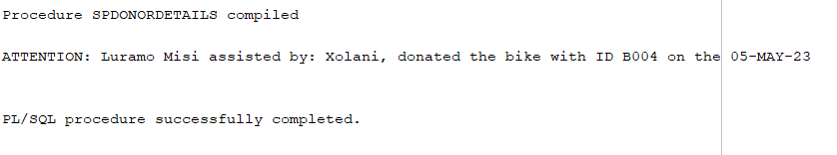

Question 5 (Matching Sample Output)
-- Creating the stored procedure spDonorDetails
CREATE OR REPLACE PROCEDURE spDonorDetails(p_bike_id IN VARCHAR2) IS
-- Declare variables to hold the retrieved data
v_donor_name VARCHAR2(100);
v_contact_no VARCHAR2(15);
v_volunteer_fname VARCHAR2(50);
v_donation_date DATE;
v_bike_description VARCHAR2(100);
BEGIN
-- Select statement to retrieve donor and donation details
SELECT
d.DONOR_FNAME || ' ' || d.DONOR_LNAME,
d.CONTACT_NO,
v.VOL_FNAME,
don.DONATION_DATE,
b.DESCRIPTION
INTO
v_donor_name,
v_contact_no,
v_volunteer_fname,
v_donation_date,
v_bike_description
FROM
DONOR d
JOIN
DONATION don ON d.DONOR_ID = don.DONOR_ID
JOIN
VOLUNTEER v ON don.VOLUNTEER_ID = v.VOL_ID
JOIN
BIKE b ON don.BIKE_ID = b.BIKE_ID
WHERE
don.BIKE_ID = p_bike_id;

-- Display the retrieved information
DBMS_OUTPUT.PUT_LINE('ATTENTION: ' || v_donor_name || ' assisted by: ' || v_volunteer_fname ||
', donated the ' || v_bike_description || ' on the ' || TO_CHAR(v_donation_date, 'DD-MON-YY'));
EXCEPTION
WHEN NO_DATA_FOUND THEN
DBMS_OUTPUT.PUT_LINE('No donation found for the specified Bike ID.');
WHEN OTHERS THEN
DBMS_OUTPUT.PUT_LINE('An error occurred: ' || SQLERRM);
END;
/

-- Enable DBMS_OUTPUT
SET SERVEROUTPUT ON;

-- Execute the stored procedure
BEGIN
spDonorDetails('B004');
END;
/
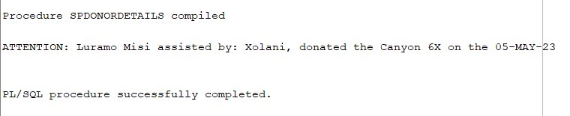

Question 6

-- Create a function to calculate the total value of bikes donated by a specific donor
CREATE OR REPLACE FUNCTION fn_total_donation_value(p_donor_id IN VARCHAR2) RETURN NUMBER IS
-- Declare a variable to hold the total value
v_total_value NUMBER := 0;
BEGIN
-- Select statement to sum the value of donations by the donor
SELECT SUM(VALUE) INTO v_total_value
FROM DONATION
WHERE DONOR_ID = p_donor_id;

-- Return the total value
RETURN v_total_value;
EXCEPTION
WHEN NO_DATA_FOUND THEN
-- Handle case where no donations found for the given donor
RETURN 0;
WHEN OTHERS THEN
-- Handle any other exceptions
DBMS_OUTPUT.PUT_LINE('An error occurred: ' || SQLERRM);
RETURN NULL;
END;
/

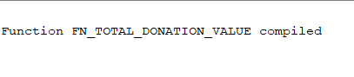

-- Enable DBMS_OUTPUT
SET SERVEROUTPUT ON;

-- Execute the function to get the total donation value for a specific donor
DECLARE
v_donor_id VARCHAR2(10) := 'DID11'; -- Example donor ID
v_total_value NUMBER;
BEGIN
-- Call the function
v_total_value := fn_total_donation_value(v_donor_id);

-- Display the result
DBMS_OUTPUT.PUT_LINE('Total value of bikes donated by donor ' || v_donor_id || ': R' || v_total_value);
END;
/

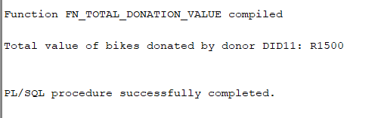

-- Create a function to calculate the total value of bikes donated by a specific donor
CREATE OR REPLACE FUNCTION fn_total_donation_value(p_donor_id IN VARCHAR2) RETURN NUMBER IS
-- Declare a variable to hold the total value
v_total_value NUMBER := 0;
BEGIN
-- Select statement to sum the value of donations by the donor
SELECT SUM(VALUE) INTO v_total_value
FROM DONATION
WHERE DONOR_ID = p_donor_id;

-- Return the total value
RETURN v_total_value;
EXCEPTION
WHEN NO_DATA_FOUND THEN
-- Handle case where no donations found for the given donor
RETURN 0;
WHEN OTHERS THEN
-- Handle any other exceptions
DBMS_OUTPUT.PUT_LINE('An error occurred: ' || SQLERRM);
RETURN NULL;
END;
/

-- Enable DBMS_OUTPUT
SET SERVEROUTPUT ON;

-- Execute the function to get the total donation value for a specific donor
DECLARE
v_donor_id VARCHAR2(10) := 'DID11'; -- Example donor ID
v_total_value NUMBER;
BEGIN
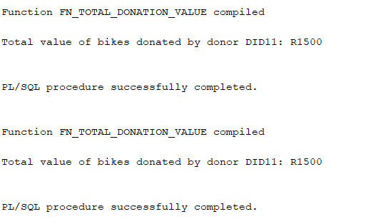
-- Call the function
v_total_value := fn_total_donation_value(v_donor_id);

-- Display the result
DBMS_OUTPUT.PUT_LINE('Total value of bikes donated by donor ' || v_donor_id || ': R' || v_total_value);
END;
/

Question 7
DECLARE
v_bike_id VARCHAR2(10);
v_description VARCHAR2(100);
v_bike_type VARCHAR2(50);
v_manufacturer VARCHAR2(50);
v_value NUMBER;
v_status VARCHAR2(3);

CURSOR bike_cursor IS
SELECT BIKE.BIKE_ID, BIKE.DESCRIPTION, BIKE.BIKE_TYPE, BIKE.MANUFACTURER, DONATION.VALUE
FROM BIKE
JOIN DONATION ON BIKE.BIKE_ID = DONATION.BIKE_ID;
BEGIN
OPEN bike_cursor;
LOOP
FETCH bike_cursor INTO v_bike_id, v_description, v_bike_type, v_manufacturer, v_value;
EXIT WHEN bike_cursor%NOTFOUND;

-- Determine the bike status based on the value
IF v_value > 3000 THEN
v_status := '***';
ELSIF v_value > 1500 THEN
v_status := '**';
ELSE
v_status := '*';
END IF;

-- Display the results
DBMS_OUTPUT.PUT_LINE('BIKE ID: ' || v_bike_id);
DBMS_OUTPUT.PUT_LINE('BIKE TYPE: ' || v_bike_type);
DBMS_OUTPUT.PUT_LINE('BIKE MANUFACTURER: ' || v_manufacturer);
DBMS_OUTPUT.PUT_LINE('BIKE VALUE: R' || v_value);
DBMS_OUTPUT.PUT_LINE('STATUS: ' || v_status);
DBMS_OUTPUT.PUT_LINE('------------------------------------------------');
END LOOP;
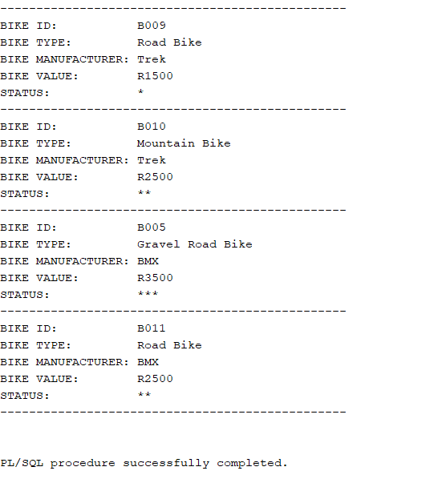
CLOSE bike_cursor;
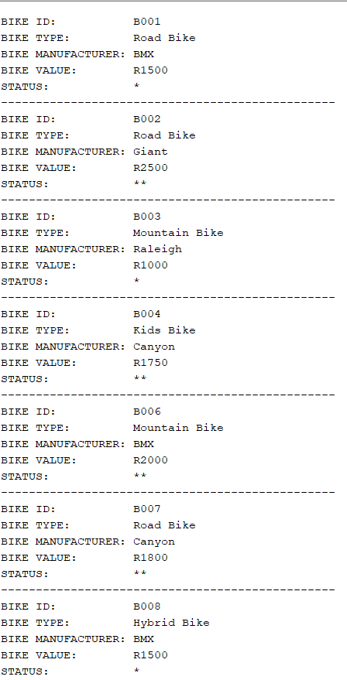
END;
/

Question 8
SELECT
BIKE.BIKE_ID,
BIKE.BIKE_TYPE,
BIKE.MANUFACTURER,
DONATION.VALUE,
CASE
WHEN DONATION.VALUE > 3000 THEN '***'
WHEN DONATION.VALUE > 1500 THEN '**'
ELSE '*'
END AS STATUS
FROM
BIKE
JOIN
DONATION ON BIKE.BIKE_ID = DONATION.BIKE_ID
ORDER BY
BIKE.BIKE_ID;

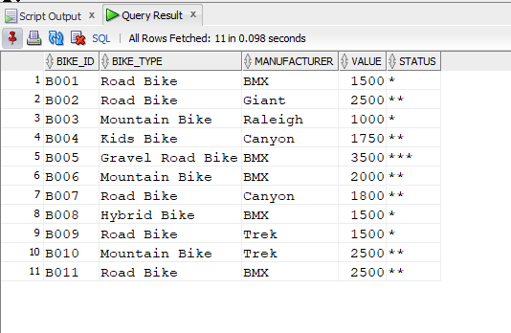

Question 9
9.1 Preventing deletions
Triggers cant be created on this schema because we don’t have the permission to do so and no sample output could be provided for this question

-- Create a trigger to prevent deletions from the DONATION table
CREATE OR REPLACE TRIGGER prevent_donation_deletion
BEFORE DELETE ON DONATION
FOR EACH ROW
BEGIN
-- Raise an application error to prevent deletion
RAISE_APPLICATION_ERROR(-20001, 'Deletion from the DONATION table is not allowed.');
END;
/

--CODE TO TRIGGER THE TRIGGER
-- Attempt to delete a record from the DONATION table to test the trigger
DELETE FROM DONATION WHERE DONATION_ID = 1;

9.2 Ensuring a valid bike value on update
Triggers cant be created on this schema because we don’t have the permission to do so and no sample output could be provided for this question

-- Create a trigger to validate bike value on update
CREATE OR REPLACE TRIGGER validate_bike_value
BEFORE UPDATE ON DONATION
FOR EACH ROW
BEGIN
-- Check if the new value is greater than 0
IF :NEW.VALUE <= 0 THEN
-- Raise an application error if the value is invalid
RAISE_APPLICATION_ERROR(-20002, 'Bike value must be greater than 0.');
END IF;
END;
/
--CODE TO TRIGGER THE TRIGGER
-- Attempt to update a record in the DONATION table with an invalid value to test the trigger
UPDATE DONATION SET VALUE = -100 WHERE DONATION_ID = 2;

Question 10
Technical Report on Ensuring Confidentiality, Integrity, and Availability for BikesRUs Outlet Data
Introduction
The BikesRUs Outlet, located in Gugulethu, operates with a mission to provide affordable transportation to underprivileged communities. With data playing a critical role in its operations, ensuring the confidentiality, integrity, and availability (CIA) of this data is paramount. This report outlines strategies, tools, and technologies to uphold these principles, thereby securing the outlet's information assets.
Confidentiality
According to ManageEngine (2024), Confidentiality ensures that sensitive information is accessible only to authorized individuals. For BikesRUs, this involves protecting donor details, volunteer information, and financial records from unauthorized access.
Tools and Platforms
- Encryption: According to ManageEngine (2024), Encryption transforms data into a secure format that is unreadable to unauthorized users. Implementing encryption at rest and in transit ensures that even if data is intercepted or accessed unlawfully, it remains unintelligible.
  - At Rest: Encrypting databases and storage devices. For example, using Oracle Advanced Security for Transparent Data Encryption (TDE).
  - In Transit: Using Transport Layer Security (TLS) to encrypt data transmitted over networks.
Sample Code (Encrypting Data Using Oracle TDE):

ENCRYPTING DOESN’T WORK CAUSE OF THE SYS SCHEMA PERMISSIONS THAT DON’T ALLOW ENCRYPTING DATA

This code is meant to simply encrypt the table column

-- Enable TDE and create a wallet
ADMINISTER KEY MANAGEMENT SET KEYSTORE OPEN IDENTIFIED BY "the_wallet_password"; (don’t work cause of permissions)
ADMINISTER KEY MANAGEMENT SET ENCRYPTION KEY IDENTIFIED BY " the_wallet_password”;
-- Encrypt the table column
ALTER TABLE DONOR MODIFY (EMAIL ENCRYPT USING 'AES256');

- Access Controls: According to Kingsley (2024), Access controls restrict who can view or use the data. Implementing role-based access control (RBAC) ensures that users have only the permissions necessary for their roles.
  - Oracle DBMS_RLS: Using Oracle’s Virtual Private Database (VPD) for fine-grained access control.
Sample Code (Setting Up RBAC):
sql
-- Create roles
CREATE ROLE C##donor_admin;
CREATE ROLE C##volunteer_admin;

-- Grant privileges to roles
GRANT SELECT, INSERT, UPDATE ON DONOR TO C##donor_admin;
GRANT SELECT, INSERT, UPDATE ON VOLUNTEER TO C##volunteer_admin; C
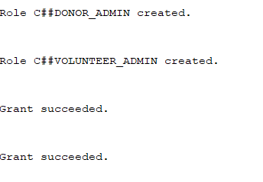

-- Create users
CREATE USER C##user1 IDENTIFIED BY password1;
CREATE USER C##user2 IDENTIFIED BY password2;
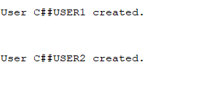
-- Assign roles to users
GRANT C##donor_admin TO C##user1;
GRANT C##volunteer_admin TO C##user2;
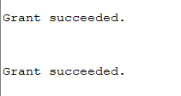

Integrity
According to (Kingsley, 2024),Integrity in the context of data security refers to the accuracy, consistency, and trustworthiness of data over its entire lifecycle. For BikesRUs, ensuring data integrity means maintaining the correctness and reliability of donor details, volunteer records, bike inventory, and transaction histories, so they remain unaltered and accurate.
Tools and Platforms:
- Checksums and Hashing: These techniques verify data integrity by generating unique hash values for data. Any alteration in data results in a different hash value, signaling a potential breach.
- Checksums: According to Kingsley (2024), A checksum is a simple method used to detect errors in data. It involves running a series of operations on the data, resulting in a fixed-size string. When data is received, the checksum is recalculated and compared to the original. If the checksums match, the data is considered intact.
- Hashing: According to Gargan (2024), Hashing involves transforming data into a fixed-size string of characters, typically for security purposes. Hash functions are designed to be fast and are used in various aspects of cybersecurity, including verifying data integrity. Even a slight change in data will result in a completely different hash value, making it an effective way to detect tampering.
- Oracle DBMS_CRYPTO: Using cryptographic functions to hash and verify data integrity.

Sample Code (Generating and Verifying Hashes):

DECLARE
v_hash RAW(256);
BEGIN
-- Generate hash value for a data column
SELECT DBMS_CRYPTO.HASH(UTL_RAW.CAST_TO_RAW(EMAIL), 3) INTO v_hash FROM DONOR WHERE DONOR_ID = 'DID11';
DBMS_OUTPUT.PUT_LINE('Hash Value: ' || v_hash);
END;

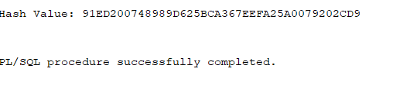
- Audit Trails: According to RiskRecon (2024), Audit trails involve recording all changes and access to the data, which helps in tracking the history of data modifications. This is critical in identifying unauthorized changes and ensuring that any alterations are appropriately logged and traceable.
  - Oracle Audit Vault: Captures and reports on database activity to identify and prevent suspicious behaviour.
Sample Code (Enabling Auditing):

-- Enable auditing for sensitive operations
AUDIT INSERT, UPDATE, DELETE ON DONOR BY ACCESS;
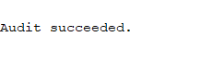

Availability
According to (Kingsley, 2024), Availability ensures that data is accessible when needed. This involves measures to protect against data loss and ensure continuous access.
Tools and Platforms
- Backup and Recovery: According to (Kingsley, 2024),Regular backups and effective recovery plans ensure data can be restored in case of loss or corruption.
  - Oracle RMAN: Robust tool for backup and recovery of Oracle databases.
Sample Code (Backing Up a Database Using RMAN):
$ rman target /

RMAN> BACKUP DATABASE;
RMAN> RESTORE DATABASE;

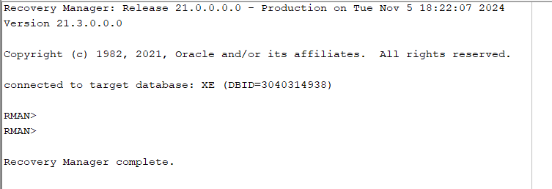
- High Availability Solutions: According to Henderson (2015), Implementing high availability solutions ensures minimal downtime and continued access to data.
  - Oracle Data Guard: Provides data protection and disaster recovery by maintaining standby databases.
Sample Code (Setting Up Data Guard):
I DIDN’T DO THIS CAUSE I DIDN’T WANT TO MESS WITH THE STUFF BUT IT SHOULD WORK IF I TRIED UNLESS THE SYS PERMISSIONS BLOCKES IT
-- Configure primary database
ALTER DATABASE ADD STANDBY LOGFILE GROUP 4 ('/path/to/standby/logfile4') SIZE 500M;

-- Set parameters for the standby database
ALTER SYSTEM SET log_archive_dest_2='SERVICE=standby_db';

Conclusion
Ensuring the confidentiality, integrity, and availability of data at BikesRUs involves a multi-faceted approach utilizing encryption, access controls, auditing, and backup solutions. By implementing these measures, BikesRUs can safeguard sensitive information, maintain accurate records, and ensure continuous access to its data. These strategies are crucial for upholding the trust of donors, volunteers, and the community that the outlet serves.
This comprehensive approach to data security not only protects the BikesRUs Outlet's operations but also ensures it can continue its mission of supporting underprivileged communities with confidence and resilience.

References
- Gargan, R. (2024). What is the CIA Triad? Importance, Tools & Techniques. [online] Netmaker.io. Available at: https://www.netmaker.io/resources/cia-triad [Accessed 5 Nov. 2024].
- Henderson, A. (2015). The CIA Triad: Confidentiality, Integrity, Availability - Panmore Institute. [online] Panmore Institute. Available at: https://panmore.com/the-cia-triad-confidentiality-integrity-availability [Accessed 5 Nov. 2024].
- Kingsley, S. (2024). The CIA Triad: Confidentiality, Integrity, Availability. [online] Veeam Software Official Blog. Available at: https://www.veeam.com/blog/cybersecurity-cia-triad-explained.html [Accessed 5 Nov. 2024].
- ManageEngine (2024). CIA security triad: Confidentiality, integrity, and availability. [online] Manageengine.com. Available at: https://www.manageengine.com/academy/cia-triad.html [Accessed 5 Nov. 2024].
- RiskRecon (2024). The CIA Triad: Securing Digital Information and Data. [online] Riskrecon.com. Available at: https://blog.riskrecon.com/the-cia-triad-securing-digital-information-and-data [Accessed 5 Nov. 2024].

